## **João Agostinho 57538**

### Code Patterns

1. Singleton Pattern

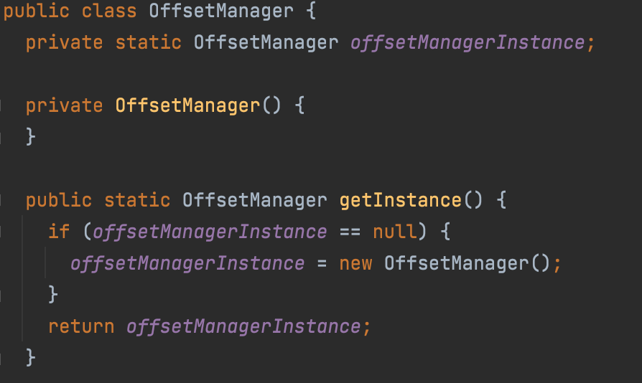

Location: biz.ganttproject.core/src/main/java/biz/ganttproject/core/chart/grid/OffsetManager.java

This implementation makes the default constructor private ( OffsetManager() ) and has a public static method ( getInstance() ) that acts as the constructor by calling the private constructor to instantiate the class (OffsetManager).

1. Command Pattern

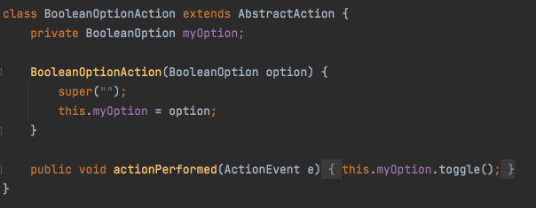

Location: ganttproject/build/classes/java/main/net/sourceforge/ganttproject/gui/options/BooleanOptionAction.class

This class is a command pattern in this program as it is used to toggle a BooleanOption when an action is performed.

1. Template method pattern



Location: ganttproject/build/classes/java/main/net/sourceforge/ganttproject/action/GPAction.class



This method is used as a template for other classses such as ExitAction

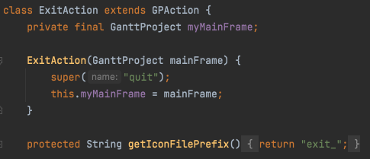

Location: ganttproject/build/classes/java/main/net/sourceforge/ganttproject/action/project/ExitAction.class